**CHAPTER 16 – STANDARD TEMPLATE LIBRARY**

**Code using several STL elements: Listing 16.19 - usealgo.cpp**

//usealgo.cpp -- using several STL elements

#include <iostream>

#include <string>

#include <vector>

#include <set>

#include <map>

#include <iterator>

#include <algorithm>

#include <cctype>

using namespace std;

char toLower(char ch) {

return tolower(ch);

}

string & ToLower(string & st);

void display(const string & s);

int main()

{

vector<string> words;

cout << "Enter words (enter quit to quit):\n";

string input;

while (cin >> input && input != "quit")

words.push_back(input);

cout << "You entered the following words:\n";

for_each(words.begin(), words.end(), display);

cout << endl;

// place words in set, converting to lowercase

set<string> wordset;

transform(words.begin(), words.end(),

insert_iterator<set<string> > (wordset, wordset.begin()),

ToLower);

cout << "\nAlphabetic list of words:\n";

for_each(wordset.begin(), wordset.end(), display);

cout << endl;

// place word and frequency in map

map<string, int> wordmap;

set<string>::iterator si;

for (si = wordset.begin(); si != wordset.end(); si++)

wordmap[*si] = count(words.begin(), words.end(), *si);

// display map contents

cout << "\nWord frequency:\n";

for (si = wordset.begin(); si != wordset.end(); si++)

cout << *si << ": " << wordmap[*si] << endl;

// cin.get();

// cin.get();

return 0;

}

string & ToLower(string & st)

{

transform(st.begin(), st.end(), st.begin(), toLower);

return st;

}

void display(const string & s)

{

cout << s << " ";

}

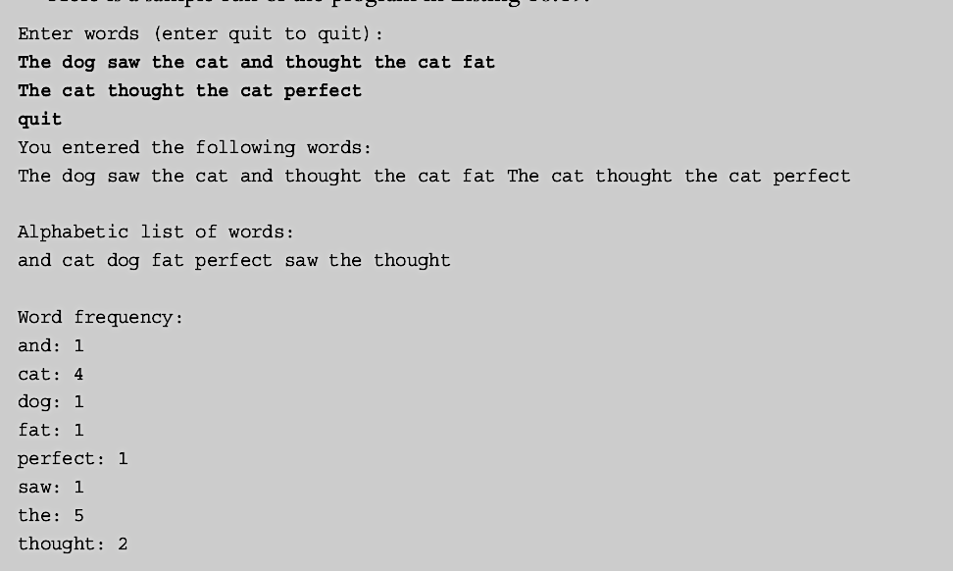

**Vector:**

**Listing 16.7 – vect1.cpp**

// vect1.cpp -- introducing the vector template

#include <iostream>

#include <string>

#include <vector>

const int NUM = 5;

int main()

{

using std::vector;

using std::string;

using std::cin;

using std::cout;

using std::endl;

vector<int> ratings(NUM);

vector<string> titles(NUM);

cout << "You will do exactly as told. You will enter\n"

<< NUM << " book titles and your ratings (0-10).\n";

int i;

for (i = 0; i < NUM; i++)

{

cout << "Enter title #" << i + 1 << ": ";

getline(cin,titles[i]);

cout << "Enter your rating (0-10): ";

cin >> ratings[i];

cin.get();

}

cout << "Thank you. You entered the following:\n"

<< "Rating\tBook\n";

for (i = 0; i < NUM; i++)

{

cout << ratings[i] << "\t" << titles[i] << endl;

}

// cin.get();

return 0;

}

**Listing 16.8 – vect2.cpp**

// vect2.cpp -- methods and iterators

#include <iostream>

#include <string>

#include <vector>

struct Review {

std::string title;

int rating;

};

bool FillReview(Review & rr);

void ShowReview(const Review & rr);

int main()

{

using std::cout;

using std::vector;

vector<Review> books;

Review temp;

while (FillReview(temp))

books.push_back(temp);

int num = books.size();

if (num > 0)

{

cout << "Thank you. You entered the following:\n"

<< "Rating\tBook\n";

for (int i = 0; i < num; i++)

ShowReview(books[i]);

cout << "Reprising:\n"

<< "Rating\tBook\n";

vector<Review>::iterator pr;

for (pr = books.begin(); pr != books.end(); pr++)

ShowReview(*pr);

vector <Review> oldlist(books); // copy constructor used

if (num > 3)

{

// remove 2 items

books.erase(books.begin() + 1, books.begin() + 3);

cout << "After erasure:\n";

for (pr = books.begin(); pr != books.end(); pr++)

ShowReview(*pr);

// insert 1 item

books.insert(books.begin(), oldlist.begin() + 1,

oldlist.begin() + 2);

cout << "After insertion:\n";

for (pr = books.begin(); pr != books.end(); pr++)

ShowReview(*pr);

}

books.swap(oldlist);

cout << "Swapping oldlist with books:\n";

for (pr = books.begin(); pr != books.end(); pr++)

ShowReview(*pr);

}

else

cout << "Nothing entered, nothing gained.\n";

// std::cin.get();

return 0;

}

bool FillReview(Review & rr)

{

std::cout << "Enter book title (quit to quit): ";

std::getline(std::cin,rr.title);

if (rr.title == "quit")

return false;

std::cout << "Enter book rating: ";

std::cin >> rr.rating;

if (!std::cin)

return false;

// get rid of rest of input line

while (std::cin.get() != '\n')

continue;

return true;

}

void ShowReview(const Review & rr)

{

std::cout << rr.rating << "\t" << rr.title << std::endl;

}

**Iterators:**

**Listing 16.10 – copyit.cpp**

// copyit.cpp -- copy() and iterators

#include <iostream>

#include <iterator>

#include <vector>

int main()

{

using namespace std;

int casts[10] = {6, 7, 2, 9 ,4 , 11, 8, 7, 10, 5};

vector<int> dice(10);

// copy from array to vector

copy(casts, casts + 10, dice.begin());

cout << "Let the dice be cast!\n";

// create an ostream iterator

ostream_iterator<int, char> out_iter(cout, " ");

// copy from vector to output

copy(dice.begin(), dice.end(), out_iter);

cout << endl;

cout <<"Implicit use of reverse iterator.\n";

copy(dice.rbegin(), dice.rend(), out_iter);

cout << endl;

cout <<"Explicit use of reverse iterator.\n";

// vector<int>::reverse_iterator ri; // use if auto doesn't work

for (auto ri = dice.rbegin(); ri != dice.rend(); ++ri)

cout << *ri << ' ';

cout << endl;

// cin.get();

return 0;

}

**Listing 16.11 – inserts.cpp**

// inserts.cpp -- copy() and insert iterators

#include <iostream>

#include <string>

#include <iterator>

#include <vector>

#include <algorithm>

void output(const std::string & s) {

std::cout << s << " ";

}

int main()

{

using namespace std;

string s1[4] = {"fine", "fish", "fashion", "fate"};

string s2[2] = {"busy", "bats"};

string s3[2] = {"silly", "singers"};

vector<string> words(4);

copy(s1, s1 + 4, words.begin());

for_each(words.begin(), words.end(), output);

cout << endl;

// construct anonymous back_insert_iterator object

copy(s2, s2 + 2, back_insert_iterator<vector<string> >(words));

for_each(words.begin(), words.end(), output);

cout << endl;

// construct anonymous insert_iterator object

copy(s3, s3 + 2, insert_iterator<vector<string> >(words, words.begin()));

for_each(words.begin(), words.end(), output);

cout << endl;

// cin.get();

return 0;

}

**List: Listing 16.12 – list.cpp**

// list.cpp -- using a list

#include <iostream>

#include <list>

#include <iterator>

#include <algorithm>

void outint(int n) { std::cout << n << " ";}

int main()

{

using namespace std;

list<int> one(5, 2); // list of 5 2s

int stuff[5] = {1,2,4,8, 6};

list<int> two;

two.insert(two.begin(),stuff, stuff + 5 );

int more[6] = {6, 4, 2, 4, 6, 5};

list<int> three(two);

three.insert(three.end(), more, more + 6);

cout << "List one: ";

for_each(one.begin(),one.end(), outint);

cout << endl << "List two: ";

for_each(two.begin(), two.end(), outint);

cout << endl << "List three: ";

for_each(three.begin(), three.end(), outint);

three.remove(2);

cout << endl << "List three minus 2s: ";

for_each(three.begin(), three.end(), outint);

three.splice(three.begin(), one);

cout << endl << "List three after splice: ";

for_each(three.begin(), three.end(), outint);

cout << endl << "List one: ";

for_each(one.begin(), one.end(), outint);

three.unique();

cout << endl << "List three after unique: ";

for_each(three.begin(), three.end(), outint);

three.sort();

three.unique();

cout << endl << "List three after sort & unique: ";

for_each(three.begin(), three.end(), outint);

two.sort();

three.merge(two);

cout << endl << "Sorted two merged into three: ";

for_each(three.begin(), three.end(), outint);

cout << endl;

return 0;

}

**Associative: Listing 16.13 – setops.cpp**

#include <iostream>

#include <string>

#include <set>

#include <algorithm>

#include <iterator>

int main()

{

using namespace std;

const int N = 6;

string s1[N] = {"buffoon", "thinkers", "for", "heavy", "can", "for"};

string s2[N] = {"metal", "any", "food", "elegant", "deliver","for"};

set<string> A(s1, s1 + N);

set<string> B(s2, s2 + N);

ostream_iterator<string, char> out(cout, " ");

cout << "Set A: ";

copy(A.begin(), A.end(), out);

cout << endl;

cout << "Set B: ";

copy(B.begin(), B.end(), out);

cout << endl;

cout << "Union of A and B:\n";

set_union(A.begin(), A.end(), B.begin(), B.end(), out);

cout << endl;

cout << "Intersection of A and B:\n";

set_intersection(A.begin(), A.end(), B.begin(), B.end(), out);

cout << endl;

cout << "Difference of A and B:\n";

set_difference(A.begin(), A.end(), B.begin(), B.end(), out);

cout << endl;

set<string> C;

cout << "Set C:\n";

set_union(A.begin(), A.end(), B.begin(), B.end(),

insert_iterator<set<string> >(C, C.begin()));

copy(C.begin(), C.end(), out);

cout << endl;

string s3("grungy");

C.insert(s3);

cout << "Set C after insertion:\n";

copy(C.begin(), C.end(),out);

cout << endl;

cout << "Showing a range:\n";

copy(C.lower_bound("ghost"),C.upper_bound("spook"), out);

cout << endl;

return 0;

}

**Listing 16.14 – multmap.cpp**

// multmap.cpp -- use a multimap

#include <iostream>

#include <string>

#include <map>

#include <algorithm>

typedef int KeyType;

typedef std::pair<const KeyType, std::string> Pair;

typedef std::multimap<KeyType, std::string> MapCode;

int main()

{

using namespace std;

MapCode codes;

codes.insert(Pair(415, "San Francisco"));

codes.insert(Pair(510, "Oakland"));

codes.insert(Pair(718, "Brooklyn"));

codes.insert(Pair(718, "Staten Island"));

codes.insert(Pair(415, "San Rafael"));

codes.insert(Pair(510, "Berkeley"));

cout << "Number of cities with area code 415: "

<< codes.count(415) << endl;

cout << "Number of cities with area code 718: "

<< codes.count(718) << endl;

cout << "Number of cities with area code 510: "

<< codes.count(510) << endl;

cout << "Area Code City\n";

MapCode::iterator it;

for (it = codes.begin(); it != codes.end(); ++it)

cout << " " << (*it).first << " "

<< (*it).second << endl;

pair<MapCode::iterator, MapCode::iterator>

auto range

= codes.equal_range(718);

cout << "Cities with area code 718:\n";

for (it = range.first; it != range.second; ++it)

cout << (*it).second << endl;

// cin.get();

return 0;

}

**Smart Pointers:**

**Listing 16.5 – smrtptrs.cpp**

// smrtptrs.cpp -- using three kinds of smart pointers

#include <iostream>

#include <string>

#include <memory>

class Report

{

private:

std::string str;

public:

Report(const std::string s) : str(s) { std::cout << "Object created!\n"; }

~Report() { std::cout << "Object deleted!\n"; }

void comment() const { std::cout << str << "\n"; }

};

int main()

{

{

std::auto_ptr<Report> ps (new Report("using auto_ptr"));

ps->comment(); // use -> to invoke a member function

}

{

std::shared_ptr<Report> ps (new Report("using shared_ptr"));

ps->comment();

}

{

std::unique_ptr<Report> ps (new Report("using unique_ptr"));

ps->comment();

}

// std::cin.get();

return 0;

}

**Listing 16.6 – fowl.cpp**

// fowl.cpp -- auto_ptr a poor choice

#include <iostream>

#include <string>

#include <memory>

int main()

{

using namespace std;

auto_ptr<string> films[5] =

{

auto_ptr<string> (new string("Fowl Balls")),

auto_ptr<string> (new string("Duck Walks")),

auto_ptr<string> (new string("Chicken Runs")),

auto_ptr<string> (new string("Turkey Errors")),

auto_ptr<string> (new string("Goose Eggs"))

};

auto_ptr<string> pwin;

pwin = films[2]; // films[2] loses ownership

cout << "The nominees for best avian baseball film are\n";

for (int i = 0; i < 5; i++)

cout << *films[i] << endl;

cout << "The winner is " << *pwin << "!\n";

// cin.get();

return 0;

}